**A7Wa Two sample Z tests using Excel**

In this workbook, we shall explore 2 sample tests that are available in both Excel and SPSS Statistics:

1. Two sample Z-test for two independent population means.
2. Two sample Z-test for two independent population proportions.

Contents

Two sample z-test for two independent population means 1

Check your understanding 6

Two sample z-test for two independent population proportions 6

Check your understanding 11

Two sample z-test for two independent population means

The two-sample z-test for the population means requires that the two populations being compared are approximately normally distributed and that the population standard deviations are known. The **two sample z test assumptions** are as follows:

1. Both samples are simple random samples.
2. The two samples must be independent.
3. The samples must be large enough to use a normal sampling distribution.
4. The population standard deviations are known, or the sample size is large (n ≥ 30) such that the Central Limit Theorem can be applied.

The two samples are large (n1 ≥ 30 and n2 ≥ 30) or both come from populations having normal distributions. For small samples, the normality assumption is not too important if the two samples have no outliers and the departure from normality is not too severe. When dealing with a normal sampling distribution we calculate the z test statistic using equation (1):

$z_{cal}=\frac{\left({\overline{X}}_{A}-{\overline{X}}_{B}\right)-(μ_{A}-μ_{B})}{\sqrt{\left[\frac{σ_{A}^{2}}{n_{A}}+\frac{σ_{B}^{2}}{n_{B}}\right]}}$ (1)



**Example 1**

A large organisation produces electric light bulbs in two of its factories (A and B). It is suspected that the quality of production from factory A is better than from factory B. To test this assertion the organisation collects samples from factory A and B and measures how long each light bulb works (in hours) before the light bulb fails. Both populations standard deviations are known (σA2 = 52783 and σB2 = 61560). Conduct a two-sample z test for the population mean to test this hypothesis (test at a 5% significance level).

The five-step procedure to conduct this test progresses as follows.

**Step 1 - State hypothesis**

Null hypothesis H0:  ≤ 

Alternative Hypothesis H1:  > 

The > sign implies a upper one tail test.

**Step 2 - Select test**

We now need to choose an appropriate statistical test for testing H0. From the information provided we note:

* Number of samples - two samples.
* The statistic we are testing - testing that the lifetime of light bulbs from factory A last longer than for factory B. Both population variances are known (σ2A = 52783 and σ2B = 61560).
* Size of both samples considered reasonably large (nA = 30 and nb = 32).
* Nature of population from which sample drawn - population distribution is not known but sample size large. For large n, the Central Limit Theorem states that the sample means are approximately normal distributed (nA and nB ≥ 30).

Two sample z test of the population mean.

**Step 3 - Set the level of significance**  = 0.05

**Step 4 - Extract relevant statistic**

Using equation (1) we can find the z test statistic and its critical value as follows:

|  |  |  |
| --- | --- | --- |
| Sample statistic | Sample A | Sample B |
| Sample size | 30 | 32 |
| Sample mean | 1135.33333 | 894.21575 |
| Population standard deviation | 52783 | 61560 |

Table 1

$$z_{cal}=\frac{\left({\overline{X}}_{A}-{\overline{X}}_{B}\right)}{\sqrt{\left[\frac{σ_{A}^{2}}{n_{A}}+\frac{σ_{B}^{2}}{n_{B}}\right]}}=3.9729$$

**Step 5 - Make a decision**

From statistical tables, Zcri = +1.645 at 5% one-tail.

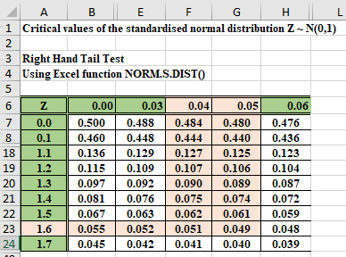

Figure 1

Does the test statistic lie within the region of rejection? The calculation of z yields a value of 3.9729 and therefore lies in the region of rejection for H0. Given zcal (3.9729) > upper zcri (1.645) we will reject H0 and accept H1.



The evidence suggests at a 5% significance level, that light bulbs from factory A have a longer lifetimes that the light bulbs from factory B.

Figure 2 illustrates the relationship between the p-value and test statistic.

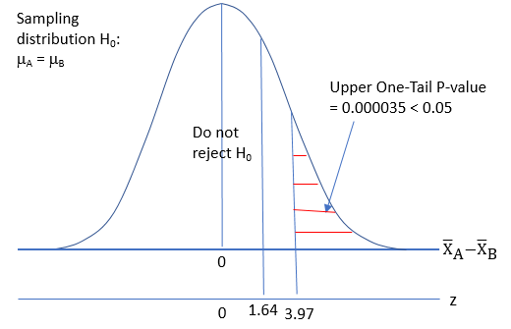

Figure 2 The value of zcal and the p-value

Excel vs SPSS solution

1. Excel – provides the test statistic, critical test statistic, and p-value.
2. SPSS – No SPSS solution.

**Excel solution**

Figure 3 illustrates the Excel solution.

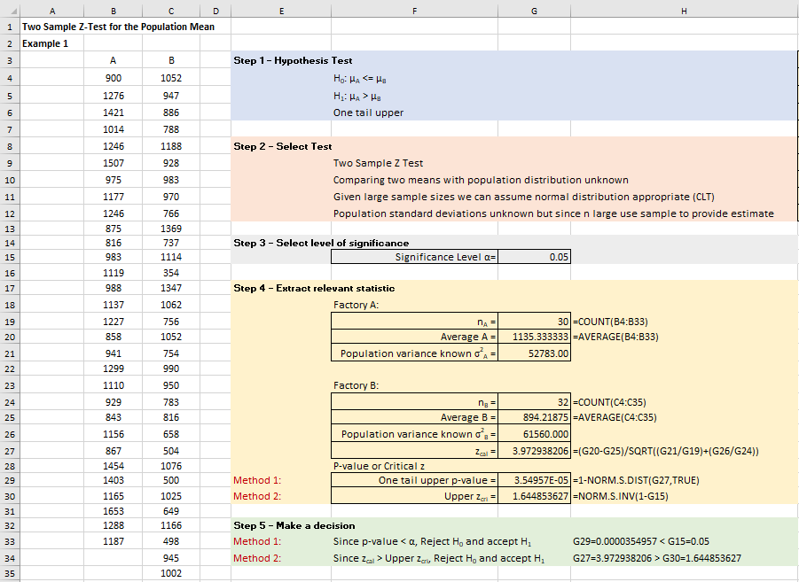

Figure 3 Excel solution for Example 1

**Excel solution**

A: Cell B4:B33 Values

B: Cell C4:C35 Values

Significance level = Cell G15 Value = 0.05

nA = Cell G19 Formula:=COUNT (B4:B33)

Sample average= Cell G20 Formula:=AVERAGE(B4:B33)

Population variance known σA2 = Cell G21 Value = 52783

nB = Cell G24 Formula =COUNT (C4:C35)

Sample average = Cell G25 Formula =AVERAGE(C4:C35)

Population variance known σB2 = Cell G26 Value = 61560

zcal = Cell G27

Formula =(G20-G25)/SQRT((G21/G19)+(G26/G24))

One tail upper p-value = Cell G29 Formula =1-NORM.S.DIST(G27,TRUE)Upper zcri = Cell G30 Formula =NORM.S.INV(1-G15)

Excel Data Analysis Ad-In solution for a two-sample z test for the population mean

As an alternative to either of the two previous methods, we can use a method embedded in Excel called Data Analysis. All the data remain the same. From the Data Analysis, we select z-test: Two Sample for Means and enter the data values as illustrated in Figure 5.

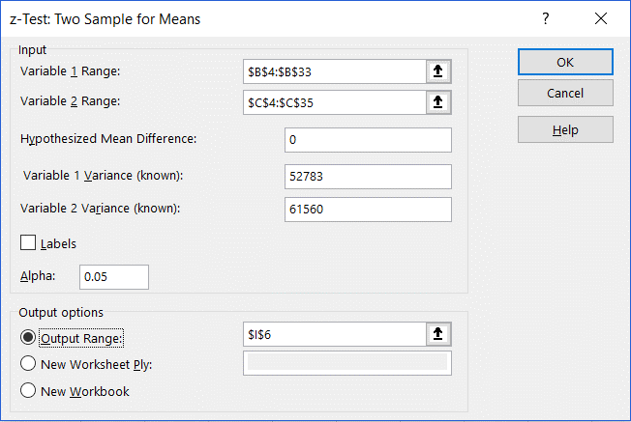

Figure 4 dialogue box for data entry

Click OK

We observe from Figure 5 below that the relevant results agree with the previous results.

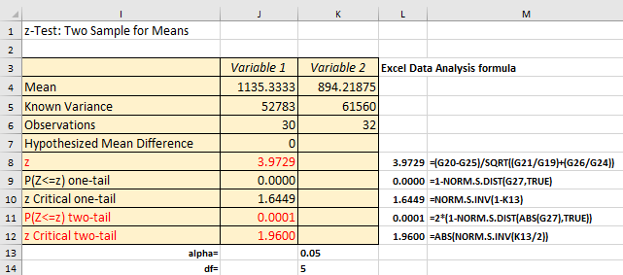

Figure 5 The output table for the z-test for two sample means and formula clarification

As we can see, the results obtained this method are fully in line with the results obtained using the previous two methods, as expected. In cells L8:L12 in Figure 6.31 we also included the formulae to illustrate how this Data Analysis menu calculated certain values.

From Excel, we established that Zcri = 1.64 (cell J10) and an upper one-tail p-value = 0.000035 (cell J9). To decide using the p-value, compare the one-tailed p-value against the one-tailed significance level of 0.05. In this example, the observed the one-tailed p-value < 0.05, we reject the null hypothesis and accept the alternative hypothesis. The evidence suggests at a 5% significance level, that light bulbs from factory A have a longer lifetimes that the light bulbs from factory B.

Checking assumptions

To use the z-test, the data are assumed to represent a random sample from a population that is normally distributed. One-sample Z tests are considered "robust" for violations of normal distribution. This means that the assumption can be violated without serious error being introduced into the test. The central limit theorem tells us that, if our sample is large, the sampling distribution of the mean will be approximately normally distributed irrespective of the shape of the population distribution. Knowing that the sampling distribution is normally distributed is what makes the one-sample Z test robust for violations of the assumption of normal distribution. If the underlying population distribution is not normal and the sample size is small, then you should not use the z-test. In this situation you should use a non-parametric equivalent test (see Chapter 7).

Check your understanding

X1 A battery manufacturer supplies a range of car batteries to car manufacturers. The 40 Amp-hour battery is manufactured at two manufacturing plants with a stated mean time between charges of 8.3 days and a variance of 1.25 days. The company regularly selects an independent random sample from the two plants with the following results:

|  |  |  |  |  |  |  |  |
| --- | --- | --- | --- | --- | --- | --- | --- |
| Plant A | | | | Plant B | | | |
| 6.72 | 10.13 | 9.31 | 7.83 | 9.93 | 8.10 | 6.27 | 8.54 |
| 9.83 | 7.38 | 9.36 | 9.23 | 10.36 | 7.81 | 9.69 | 8.51 |
| 7.15 | 6.93 | 7.23 | 8.70 | 9.06 | 7.58 | 8.01 | 9.54 |
| 7.72 | 9.32 | 8.32 | 10.65 | 8.08 | 8.35 | 7.78 | 9.08 |
| 9.20 | 8.70 | 9.32 | 8.09 | 9.82 | 6.51 | 8.33 | 7.01 |
| 11.36 | 8.50 | 8.86 | 10.06 | 9.56 | 7.98 | 8.94 | 7.06 |
| 6.38 | 7.99 | 9.34 | 6.62 | 7.81 | 6.62 | 9.82 | 9.26 |
| 9.57 | 7.23 | 8.91 | 10.74 | 7.27 | 8.14 | 9.45 | 10.26 |

Table 2

(a) For the given samples conduct an appropriate hypothesis test to test that the sample mean values are not different at the 5% level of significance.

(b) If the sample means are not significantly different test whether the population mean is 8.3 days (choose sample A to undertake the test).

X2 The Indian restaurant manager has employed two new delivery drivers and wishes to assess their performance. The following data represents the delivery times for person A and B undertaken on the same day:

|  |  |  |  |  |  |  |  |  |  |
| --- | --- | --- | --- | --- | --- | --- | --- | --- | --- |
| Person A | | | | | Person B | | | | |
| 32.9 | 25.6 | 36.2 | 34.6 | 30.3 | 31.6 | 25.5 | 36.5 | 36.0 | 36.3 |
| 29.4 | 33.5 | 32.5 | 40.7 | 32.7 | 25.5 | 28.1 | 38.8 | 32.4 | 32.8 |
| 41.2 | 35.6 | 40.8 | 32.4 | 35.3 | 34.2 | 37.5 | 33.3 | 25.9 | 37.7 |
| 40.3 | 34.6 | 30.2 | 37.1 |  | 31.0 | 33.4 | 32.3 | 33.2 |  |
| 39.3 | 36.5 | 35.0 | 32.7 |  | 35.5 | 32.6 | 31.9 | 36.8 |  |
| 30.3 | 35.7 | 40.2 | 34.2 |  | 36.5 | 34.0 | 35.9 | 25.1 |  |
| 37.5 | 38.0 | 33.4 | 33.2 |  | 36.1 | 41.4 | 29.0 | 37.6 |  |
| 45.0 | 30.7 | 37.8 | 37.7 |  | 28.9 | 29.8 | 34.3 | 34.4 |  |

Table 3

Based upon your analysis of the two samples is there any evidence that the delivery times are different (test at 5%).

Two sample z-test for two independent population proportions

The **two-sample z-test for the population proportions** can be used to test the difference between two population proportions when a sample is randomly selected from each population. The test assumptions are as follows:

1. Both samples are simple random samples.
2. The two samples must be independent.
3. The samples must be large enough to use a normal sampling distribution.
4. The population standard deviations are known, or the sample size is large (n ≥ 30) such that the Central Limit Theorem can be applied.

It can be shown that equation (2) approximately follows a standardized normal distribution for large sample sizes.

$Z= \frac{\left(p_{1}- p_{2}\right)- \left(π_{1}- π_{2}\right) }{\sqrt{\overline{p} \left(1-\overline{p}\right) \left(\frac{1}{n_{1}}+ \frac{1}{n_{2}}\right) }}$ (2)

with

$\overline{p}= \frac{X_{1}+ X_{2}}{n_{1}+ n_{2}}$ $p_{1}= \frac{X_{1}}{n_{1}}$ $p_{2}= \frac{X_{2}}{n_{2}}$

Where

|  |  |  |  |
| --- | --- | --- | --- |
| Sample size | Number of successes in sample | Proportion of successes in sample | Proportion of successes in population |
| n1 | X1 | P1 | π1 |
| n2 | X2 | P2 | π2 |

Table 4

and $\overline{p}$ is the pooled estimate of the population proportion of successes.



**Example 2**

A local police authority concerned at the number of passengers wearing rear seat belts in cars decided to undertake a series of surveys based upon two large cities. The survey consisted of two independent random samples collected from city A and B and the police authority would like to know if the proportions of passengers wearing seat belts between city A and B are different. Conduct a two-sample z test for the population proportion to test this hypothesis (test at 5%).

|  |  |  |
| --- | --- | --- |
|  | City A | City B |
| Number interviewed, n | 250 | 190 |
| Number wearing rear seat belts, X | 135 | 80 |

Table 5

The five-step procedure to conduct this test progresses as follows.

**Step 1 - State hypothesis**

Null hypothesis H0: πA = πB

Alternative Hypothesis H1: πA ≠ πB

The ≠ sign implies a two-tail test.

**Step 2 - Select test**

We now need to choose an appropriate statistical test for testing H0. From the information provided we note:

* Number of samples - two samples.
* The statistic we are testing - testing that the proportions wearing seatbelts is different between the two cities.
* Both population standard deviations are unknown.
* Size of both samples large (nA = 250 and nB = 190).
* Nature of population from which sample drawn - population distribution is not known but sample size large. For large n, the Central Limit Theorem states that the sample proportions are approximately normal distributed.

From this information, we will undertake a **two-sample z test for population proportions**.

**Step 3 - Set the level of significance**  = 0.05

**Step 4 - Extract relevant statistic**

Summary statistics

|  |  |  |
| --- | --- | --- |
| Sample statistic | City A | City B |
| Number interviewed, n | 250 | 190 |
| Number wearing rear seat belts, X | 135 | 80 |

Table 6

If H0 is true (πA - πB = 0) then equation (2) can be used to calculate the value of the test statistic

$$Z= \frac{\left(p_{A}- p_{B}\right) }{\sqrt{\overline{p} \left(1-\overline{p}\right) \left(\frac{1}{n_{A}}+ \frac{1}{n_{B}}\right) }}$$

with

$$\overline{p}= \frac{X_{A}+ X_{B}}{n_{A}+ n_{B}}= \frac{135+80}{250+190}= \frac{215}{440}= 0.488636363$$

$$p_{A}= \frac{X_{A}}{n_{A}}= \frac{135}{250}= 0.54$$

$$p_{B}= \frac{X_{B}}{n_{B}}= \frac{80}{190}= 0.421052631$$

$$\text{Z= }\frac{\left(\text{0.54- 0.421052631}\right) }{\sqrt{\text{0.488636363 }\left(\text{1-0.488636363}\right) \left(\frac{\text{1}}{\text{250}}\text{+ }\frac{\text{1}}{\text{190}}\right) }}$$

Z = 2.47

**Step 5 - Make a decision**

From statistical tables, Zcri = ± 1.96 at 5% significance, two-tail.

|  |  |  |  |  |  |  |
| --- | --- | --- | --- | --- | --- | --- |
| **Z** | **0.00** | **0.05** | **0.06** | **0.07** | **0.08** | **0.09** |
| **0.0** | **0.500** | **0.480** | **0.476** | **0.472** | **0.468** | **0.464** |
| **0.1** | **0.460** | **0.440** | **0.436** | **0.433** | **0.429** | **0.425** |
| **0.2** | **0.421** | **0.401** | **0.397** | **0.394** | **0.390** | **0.386** |
| **1.5** | **0.067** | **0.061** | **0.059** | **0.058** | **0.057** | **0.056** |
| **1.6** | **0.055** | **0.049** | **0.048** | **0.047** | **0.046** | **0.046** |
| **1.7** | **0.045** | **0.040** | **0.039** | **0.038** | **0.038** | **0.037** |
| **1.8** | **0.036** | **0.032** | **0.031** | **0.031** | **0.030** | **0.029** |
| **1.9** | **0.029** | **0.026** | **0.025** | **0.024** | **0.024** | **0.023** |
| **2.0** | **0.023** | **0.020** | **0.020** | **0.019** | **0.019** | **0.018** |
| **2.1** | **0.018** | **0.016** | **0.015** | **0.015** | **0.015** | **0.014** |

Table 7

Does the test statistic lie within the region of rejection?

The calculation of Z yields a value of 2.47 and therefore lies in the region of rejection for H0. Given zcal (2.49) > upper two tail zcri (+ 1.96) we will reject H0 and accept H1.

It can be concluded that based upon the evidence that a significant difference exists between the proportions of rear passengers wearing seat belts between city A and B.

Furthermore, the evidence suggests that the proportion wearing seat belts is higher for city A. To test this, we could undertake an upper one tail test to test whether the proportion for city A is significantly larger than for city B. It should be noted that the decision will change if you choose a 1% level of significance. Figure 6 illustrates the relationship between the p-value and test statistic

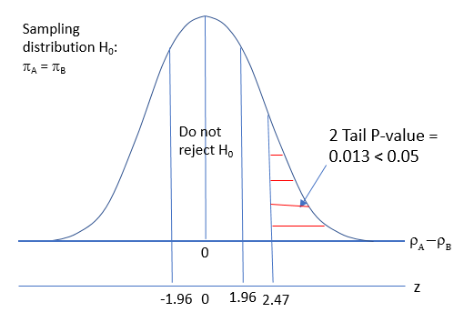

Figure 6 Relationship between the p-value and test statistic

Excel vs SPSS solution

1. Excel – provides the test statistic, critical test statistic, and p-value.
2. SPSS – No SPSS solution.

**Excel solution**

Figure 7 illustrates the Excel solution.

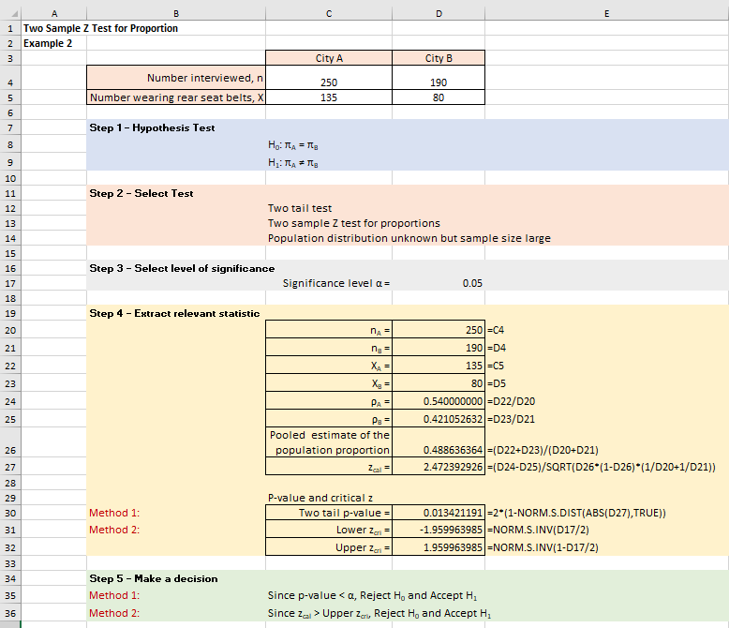

Figure 7 Excel solution for Example 6.7

**Excel solution**

nA = Cell C4 Value = 250

nB = Cell D4 Value = 190

XA = Cell C5 Value = 135

XB = Cell D5 Value = 80

Significance level = Cell D17 Value = 0.05

nA = Cell D20 Formula:=C4

nB = Cell D21 Formula:=D4

XA = Cell D22 Formula:=C5

XB = Cell D23 Formula:=D5

A = Cell D24 Formula:=D22/D20

B = Cell D25 Formula:=D23/D21

Pooled estimate of π = Cell D26 Formula:=(D22+D23)/(D20+D21)

z = Cell D27

Formula:=(D24-D25)/SQRT(D26*(1-D26)*(1/D20+1/D21))

Two tail p-value = Cell D30 Formula:=2*(1-NORM.S.DIST(ABS(D27),TRUE))

Lower zcri = Cell D31 Formula:=NORM.S.INV(D17/2)

Upper zcri = Cell D32 Formula:=NORM.S.INV(1-D17/2)

From Excel, Zcal = 2.47, two-tail Zcri = ± 1.96, and two-tail p-value = 0.013. Therefore, Zcal > Zcri and two-tail p-value < 0.05. Accept the alternative hypothesis. It can be concluded that based upon the evidence that a significant difference exists between the proportions of rear passengers wearing seat belts between city A and B.

Checking assumptions

To use the z-test, the data are assumed to represent a random sample from a population that is normally distributed. One-sample Z tests are considered "robust" for violations of normal distribution. This means that the assumption can be violated without serious error being introduced into the test. The central limit theorem tells us that, if our sample is large, the sampling distribution of the mean will be approximately normally distributed irrespective of the shape of the population distribution. Knowing that the sampling distribution is normally distributed is what makes the one-sample Z test robust for violations of the assumption of normal distribution. If the underlying population distribution is not normal and the sample size is small, then you should not use the z-test. In this situation you should use a non-parametric equivalent test (see Chapter 7).

Check your understanding

X3 During a national election a national newspaper wanted to assess whether there was a similar voting pattern for a political party between two towns in the North East of England. The sample results are illustrated in Table 6.15

|  |  |  |
| --- | --- | --- |
|  | Town A | Town B |
| Number interviewed, N | 456 | 345 |
| Intention to vote for party, n | 243 | 212 |

Table 8

Assess whether there is a significant difference in voting intentions between town A and town B. (test at 5%).

X4 A national airline keeps a record of luggage misplaced at two European airports during one week in the summer of 2006. The sample results are illustrated in Table 6.16

|  |  |  |
| --- | --- | --- |
|  | Airport A | Airport B |
| Total number of items processed, N | 15596 | 25789 |
| Number of items of luggage misplaced, n | 123 | 167 |

Table 9

Assess whether there is a significant difference in misplaced luggage between the two airports (test at 5%).